1. Difference Between Frontend, Backend, and Full-Stack Development
Type | Description | Real-World Example
Frontend | Deals with what users see and interact with on a website — the UI. Built using HTML, CSS, and JavaScript. | When you visit Amazon, the product listings, buttons, and layout are all part of the frontend.
Backend | Handles the logic, database operations, authentication, and server communication. Typically built with Node.js, Python (Django/Flask), Java (Spring), or PHP. | When you add an item to the cart on Amazon, the backend saves that info in your account’s database.
Full-Stack | A developer who handles both frontend and backend tasks — building the entire web app. | A solo developer creating a blogging platform using React (frontend) + Node.js + MongoDB (backend).

2. Simple Diagram — Client-Server Model
HTTP Request
Browser ----------------------------> Web Server
HTTP Response
(Client) <---------------------------- (Backend)
↑ |
| ↓
| Database
Explanation:
- The client (browser) sends an HTTP request (like asking for a web page).
- The server processes it, interacts with a database if needed, and sends back an HTTP response (usually HTML, CSS, JS).
- The browser renders the page for the user.

3. How a Browser Requests and Displays a Web Page
- User enters a URL in the address bar (e.g., https://www.example.com).
- DNS Lookup: The browser finds the IP address of the domain.
- HTTP/HTTPS Request: The browser sends a request to the web server.
- Server Processing: The server locates the requested resource (like index.html) or dynamically generates it.
- Response: The server sends back the content (HTML, CSS, JS, images).
- Rendering:
  - The browser parses HTML → builds the DOM.
  - It parses CSS → builds the CSSOM.
  - It executes JavaScript.
  - The Render Tree combines everything and paints pixels to the screen.

4. Tools for Setting Up a Web Development Environment
Tool | Purpose
VS Code | Code editor with syntax highlighting, extensions, and debugging.
Web Browser (e.g., Chrome) | Used to test and inspect web pages.
Node.js & npm | Runs JavaScript on the server and manages packages.
Git & GitHub | Version control and remote code repository.
Prettier / ESLint | Code formatting and linting tools.
Live Server (VS Code Extension) | Automatically reloads browser when files change.

5. What is a Web Server?
A web server is software (and sometimes hardware) that stores, processes, and delivers web pages to users over HTTP or HTTPS.
Common Web Servers:
- Apache HTTP Server
- Nginx
- Microsoft IIS
- LiteSpeed
- Node.js (Express) — often used for lightweight setups.
Example:
When you open www.github.com, a web server hosted by GitHub delivers the page content to your browser.

6. Roles in a Web Project
Role | Responsibilities
Frontend Developer | Builds user interfaces using HTML, CSS, and JS frameworks (React, Vue, etc.). Ensures responsiveness and UX.
Backend Developer | Manages server logic, APIs, and database communication. Handles authentication, file storage, and business logic.
Database Administrator (DBA) | Designs, manages, and optimizes databases. Ensures data security, backups, and performance tuning.

7. Install VS Code and Configure for Web Development
Steps:
- Download VS Code from https://code.visualstudio.com.
- Install extensions:
  - Live Server (for live preview)
  - Prettier (for code formatting)
  - HTML CSS Support
- Create a new project folder → add index.html, style.css, and script.js.
- Right-click index.html → “Open with Live Server.”
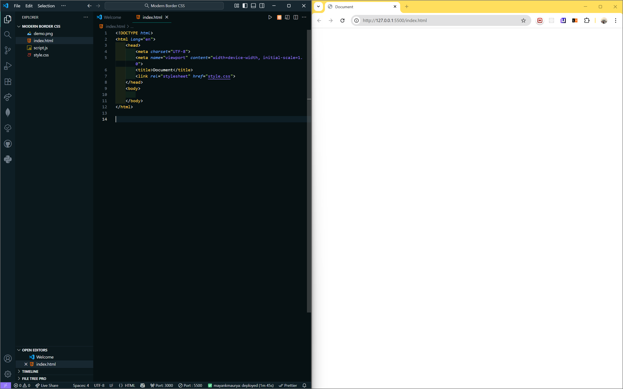

8. Static vs Dynamic Websites
Type | Description | Example
Static Website | Fixed content — same for every visitor. Built using only HTML, CSS, and JS. | A personal portfolio website or a product landing page.
Dynamic Website | Content changes based on user or data — uses backend and databases. | Facebook, Amazon, YouTube.
9. Five Web Browsers and Their Rendering Engines
Browser | Rendering Engine | Notes
Google Chrome | Blink | Fast, modern, supports latest web standards.
Mozilla Firefox | Gecko | Independent engine, strong privacy features.
Safari | WebKit | Optimized for Apple devices.
Microsoft Edge | Blink (previously EdgeHTML) | Now Chromium-based, same engine as Chrome.
Opera | Blink | Shares Chrome’s engine, with built-in VPN/ad blocker.
Rendering engine = software that interprets HTML/CSS/JS and draws the page visually.

10. Basic Web Architecture Flow (Labeled Diagram)
HTTP Request
Browser --------------------------> Web Server
HTTP Response
(Client) <-------------------------- (Backend/API)
|
Database
↑
API Layer

Flow Explanation:
- Client sends a request.
- Server processes it.
- Server may query/update database.
- Data flows back through the API to the client.

